FOR LOOP
Q1. Print numbers 1 to 5
for(i in 1:5){
print(i)
}

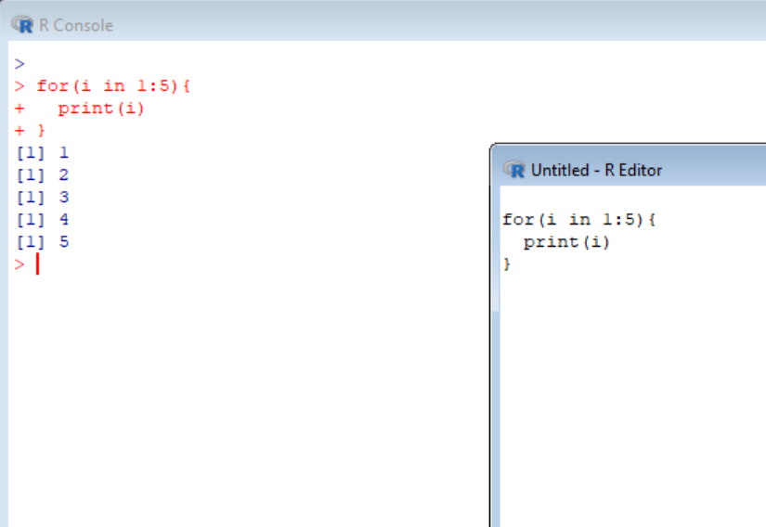
Q2. Print multiplication table of 2
for(i in 1:10){
print(2*i)
}
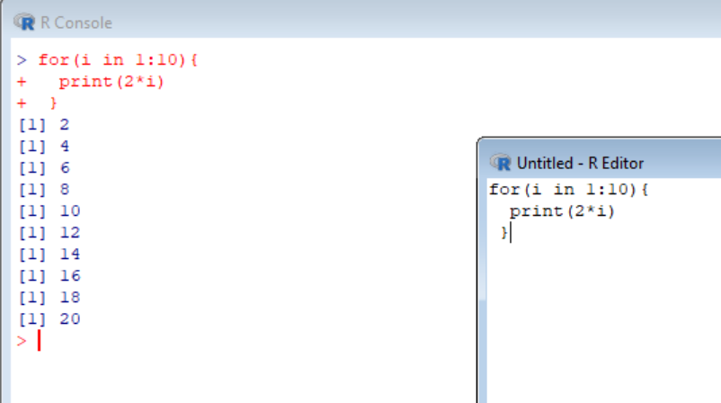

WHILE LOOP
Q1. Print numbers 1 to 5
i<-1
while(i<=5){
print(i)
i<-i+1
}
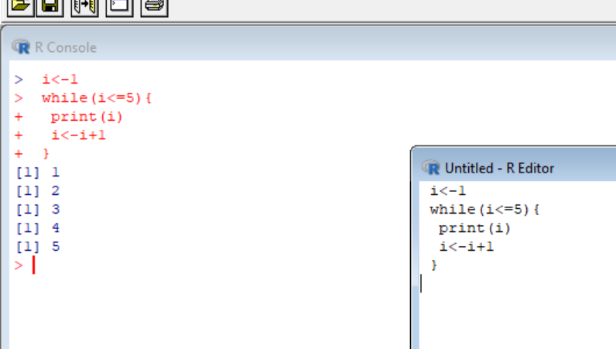

REPEAT LOOP
Q1. Print 1 to 5 using repeat
i<-1
repeat{
print(i)
i<-i+1
if(i>5) break
}
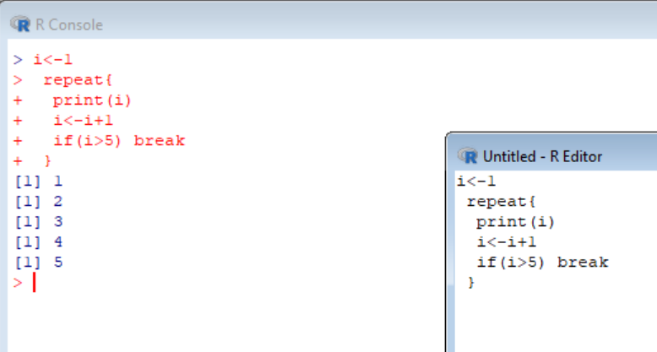

DO WHILE (simulated)
Q1. Execute at least once
i<-1
repeat{
print(i)
i<-i+1
if(!(i<=5)) break
}

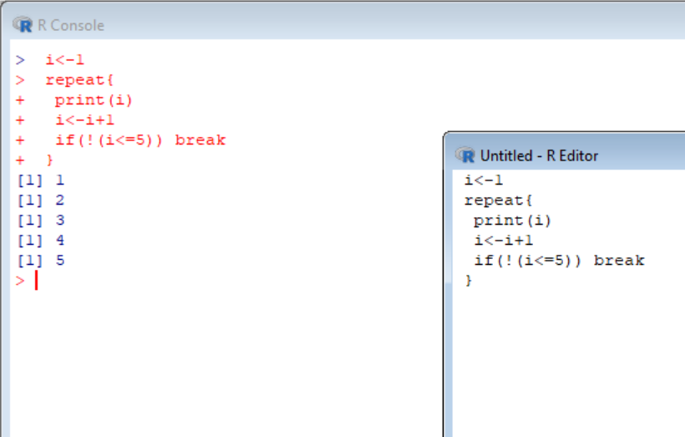

BREAK
Q1. Stop at 5
for(i in 1:10){
if(i==5) break
print(i)
}
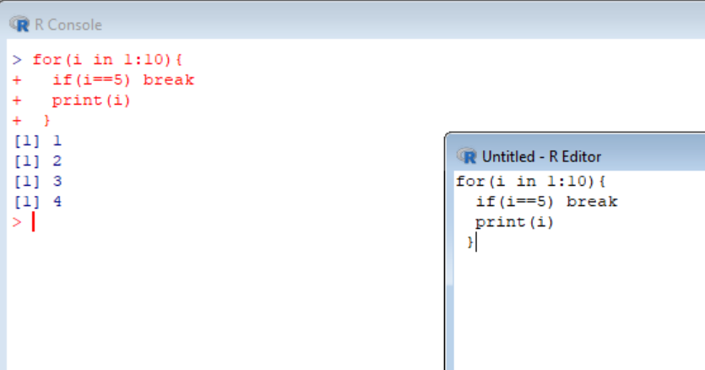

NEXT
Q1. Skip even numbers
for(i in 1:10){
if(i%%2==0) next
print(i)
}
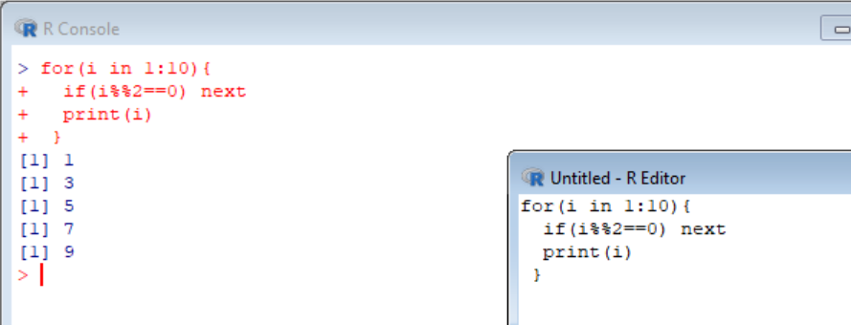

APPLY
Q1. Row sums of matrix
m<-matrix(1:9,nrow=3)
apply(m,1,sum)
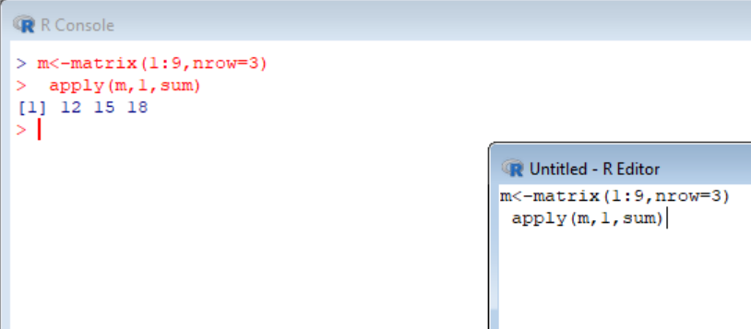

LAPPLY
Q1. Square list elements
x<-list(1,2,3,4)
lapply(x,function(i)i^2)
